Heart-Healthy Benefits of Exercise
Your Body Benefits from Your Hard Work
- By Jen Mueller,
- "Exercise improves your health." You hear it all the time, but what does that really mean? How much of a difference can exercise make in your life, and how much do you really need to do? You’ll be happy to know that you don’t need to spend countless hours in the gym to achieve the heart-health benefits of getting active.

Lower Blood Pressure
- A study by the National Institutes of Health showed that regular exercise (30+ minutes of moderate activity, 5+ days a week) reduced blood pressure in 75% of subjects who had high blood pressure. The reductions were approximately 10 mmHg for both systolic and diastolic blood pressures.
- According to the American College of Sports Medicine, the blood pressure lowering effects of exercise can be observed as soon as one to three hours after a single 30- 45 minute workout! This response can linger for up to nine hours post-exercise. Permanent blood pressure changes can be seen as early as three weeks to three months after beginning an exercise program.

Improve Cholesterol Levels
- A 2001 review involving patients with high cholesterol demonstrated a change in HDL (good cholesterol) and LDL (bad cholesterol) levels after a 12-week exercise program. On average, subjects experienced a 4.6% increase in HDL, a 5.0% decrease in LDL, and a 3.7% decrease in triglycerides.
- Other studies show widespread improvements in cholesterol levels are related to the amount of activity and not the intensity of exercise. The more minutes you exercise per week, the more your cholesterol levels will improve, even if accompanied by a minimal weight change.

There are easy ways to add this type of activity to your daily routine:
- Park the car farther away from your destination.
- Get on or off the bus several blocks away.
- Take the stairs instead of the elevator or escalator.
- Take fitness breaks instead of cigarette or coffee breaks. Walk, stretch or do some office exercises.
- Perform gardening, yard work, heavy house cleaning, or home-repair activities.
- Avoid labor-saving devices; turn off the self-propel option on your lawn mower or vacuum cleaner, and hide all of your TV remotes.
- Exercise while watching TV. For example, use hand weights, a stationary bike or treadmill, stretch, or perform body-weight exercises such as crunches, push ups and squats.
- Keep a pair of comfortable walking or running shoes in your car and office. You'll be ready for activity wherever you go!
- Walk while doing errands.
The good news is that it's never too late to start an active lifestyle. No matter how old you are, how unfit you feel, or how long you've been inactive, research shows that starting a more active lifestyle now—through consistent, moderate-intensity activity—can make you healthier and improve your quality of life.

10 Heart Healthy Exercise Tips

Activities as Exercise Can Help Your Heart
According to Jennifer Mieres, M.D., American Heart Association (AHA), "to get heart-healthy benefits, you need to get your heart rate up" there are dozens of activities you can do to help your heart. Whether it is a structured exercise program or just part of your daily routine, all physical activity adds up. It’s easy to follow these exercise tips at home, at work, and at play to increase the amount of physical activity in your life.

Tips to help you start a heart healthy exercise plan.
- Aerobic exercises done 30 minutes a day is excellent for increasing your heart rate. Climbing the stairs, a brisk walk, orbital exercise machine or treadmill, anything to get your heart rate up. Wii has several fun games such as Wii Sports or Wii Fit Step Aerobics – and its great exercise you can do with your kids. Make it a family affair
- Any moderate-intensity exercise like swimming, jogging, Pilates and yoga is good. Exercising your heart muscle means exercising your body. If you “don’t have time” then fit shorter but more frequent periods of time, like 5-10 minutes several times a day throughout your day. Take the stairs, park your car further away from the door, and definitely count in those house chores such as mowing the lawn, vacuuming, or a short brisk walk around the block at lunch or for a break.
- If you already do a vigorous aerobic routine or enrolled in an exercise class, then three days a week for 20 minutes a day is good.
- For adults that are 65 and older or anyone with chronic conditions or limited mobility, you need the same amount of exercise as younger people – the activity can be less intense. Use good judgment and follow your doctor’s advice. See tip #1 and plan to gradually increase activities.
- Strength training is a great complement to aerobic training and helps to prevent age-related bone and muscle-mass losses. Keep in mind that strength training doesn’t increase heart rate but does increase stamina. Use it to target areas where muscle-tone is needed and don’t forget the other muscle groups.
- With any plan, start strength training slowly and build up to heavier weights and repetitions especially if you are new or out of shape. The old adage "no pain, no gain" is more often inappropriate and can be dangerous.
- Practice balance exercises to help prevent falls and injuries. Balance techniques are used frequently as exercises in yoga or more simple forms of balancing exercises such as walking heal-to-toe, standing on one foot, or standing up and sitting down without using your hands.
- Stretching exercises done twice a week helps keep flexibility, which is very important. Consider 10 minutes of stretching twice a week to improve your flexibility
With any exercise program, it’s good to start slowly by warming up, then increasing the pace. A good cooling down afterwards is also equally important. With any new exercise plan, check with your doctor if you are at risk and follow the advice of qualified professionals.
Physical Activity & Public Health Guidelines are the most current recommendations created together by the ACSM and AHA.
Articles by Spark People and Heart.com

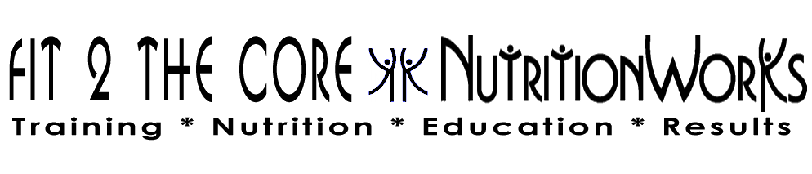
993 Oaklawn Ave., Cranston, RI 02920 401.490.2137 www.camille@nutritionworksri.com

