WILL SPECK FATHER’S DAY ROAD RACE TEAM

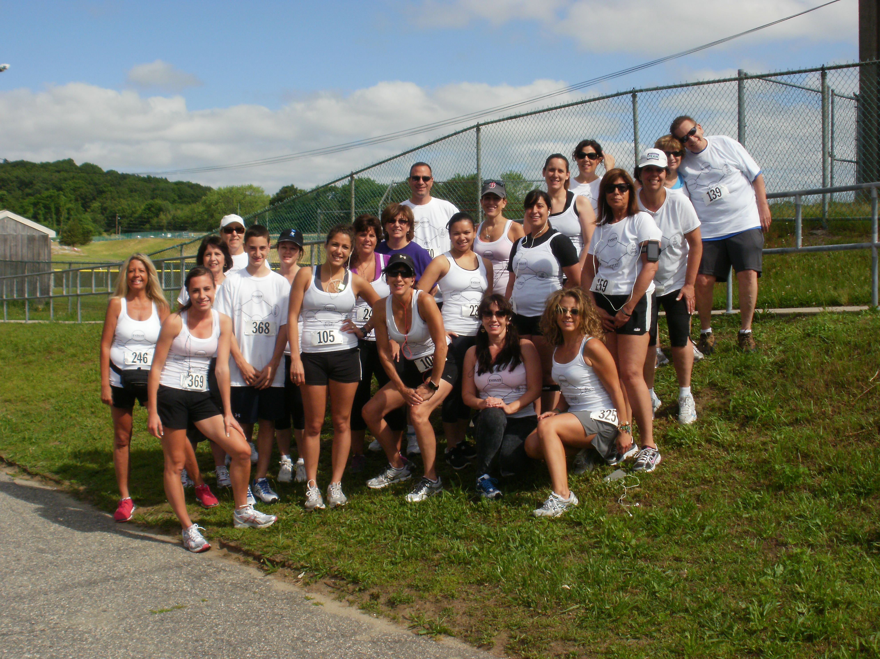
11TH Annual Will Speck Memorial 5k walk/run
Sunday June 15th 9:30am begins at Cranston West Track
Come be part of the FIT 2 THE CORE/NUTRITIONWORKS team!
Training begins Sunday May 4th, 8:00am at Johnston Memorial Park. No cost for members, non-members $5.00 weekly. Sign up today! Email camille@nutritionworksri.com or call 401.490.2137

